ASSIGNMENT 2: E-Commerce Sales Database Using SQL(objectives)

Submitted By: Devansh Saini_MMDU
Role: Data Engineer Intern

Objective
The primary goal of this task is to utilize SQL to systematically construct, manage, and analyze a relational database for an e-commerce platform. This workflow encompasses creating structured tables with strict primary and foreign key constraints, loading sample data, and ensuring overall data integrity. Furthermore, it involves applying robust filtering, mathematical aggregations, multi-table joins, and advanced database concepts such as conditional logic (CASE) and transaction management (ACID properties) to extract actionable business insights regarding sales patterns, customer behavior, and product performance.
STEP 1: LOAD DATASET (Contextual) –
1. Ensure your table 'superstore' is created and data from the CSV is imported via SQL Workbench's Table Data Import Wizard.
-- 1. Create the database
CREATE SCHEMA IF NOT EXISTS retail_analytics;

-- 2. Make it the active database
USE retail_analytics;
STEP 2: EXPLORE TABLE
-- Objective: View the schema and sample data
SELECT `Order ID`, `Order Date`, `Customer Name`, `Sales`
FROM superstore
LIMIT 5;

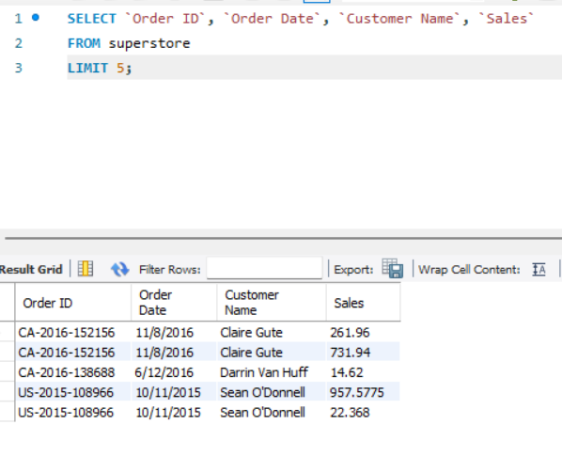
STEP 3: APPLY WHERE FILTERS
-- Objective: Find high-value Technology sales in the West region
SELECT `Order ID`, `Category`, `Region`, `Sales`
FROM superstore
WHERE `Region` = 'West'
AND `Category` = 'Technology'
AND `Sales` >= 1000
LIMIT 5;

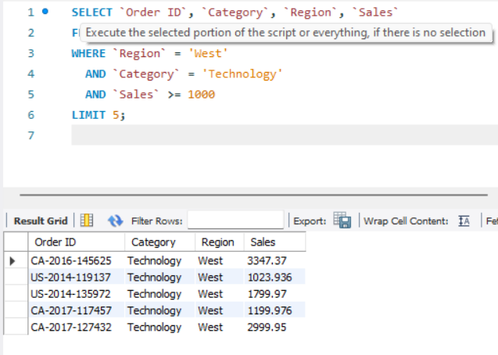

STEP 4: USE GROUP BY FOR AGGREGATIONS
-- Objective: Calculate total sales, quantity, and average profit per category
SELECT `Category`,
SUM(`Sales`) AS Total_Sales,
SUM(`Quantity`) AS Total_Quantity,
AVG(`Profit`) AS Average_Profit
FROM superstore
GROUP BY `Category`;
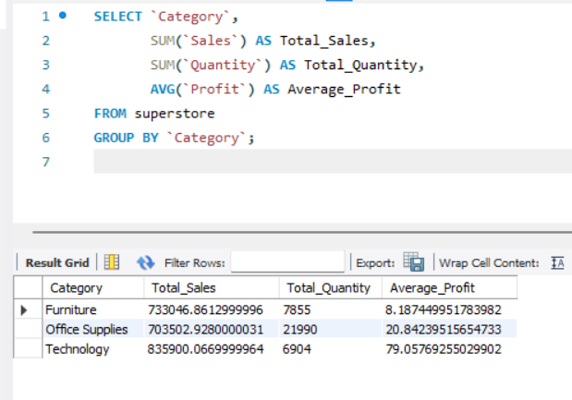

STEP 5: SORT AND LIMIT RESULTS
-- Objective: Identify the Top 5 products by total sales revenue
SELECT `Product Name`,
SUM(`Sales`) AS Total_Sales
FROM superstore
GROUP BY `Product Name`
ORDER BY Total_Sales DESC
LIMIT 5;
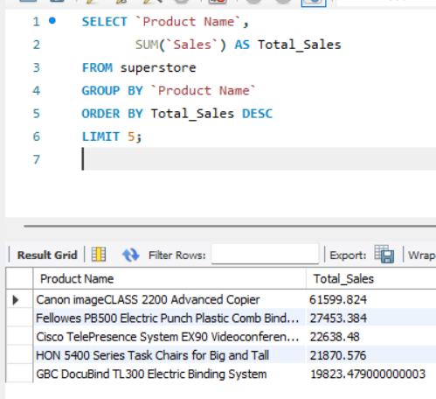

STEP 6: USE CASES

-- 6a. Monthly Trends
-- Note: Because your `Order Date` is stored as TEXT (e.g., "11/8/2016"),
-- we must use STR_TO_DATE to convert it to a real date before formatting.
SELECT DATE_FORMAT(STR_TO_DATE(`Order Date`, '%m/%d/%Y'), '%Y-%m') AS Order_Month,
SUM(`Sales`) AS Monthly_Sales
FROM superstore
GROUP BY Order_Month
ORDER BY Order_Month ASC
LIMIT 12;
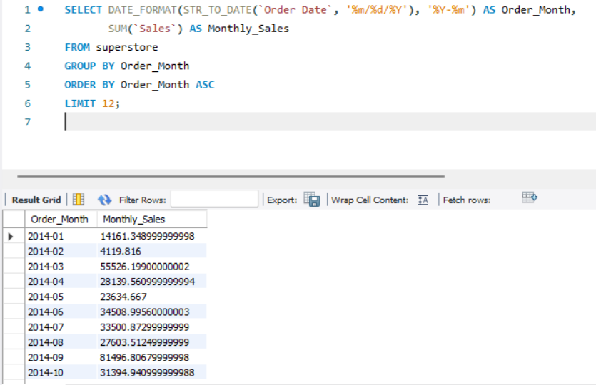

-- 6b. Top 5 Customers by Lifetime Spend
SELECT `Customer Name`,
SUM(`Sales`) AS Total_Spend
FROM superstore
GROUP BY `Customer Name`
ORDER BY Total_Spend DESC
LIMIT 5;
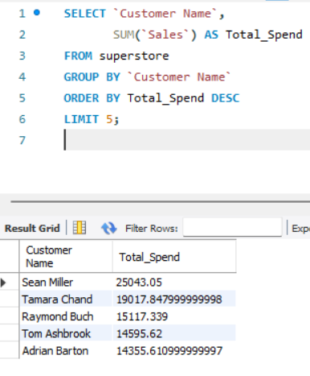

-- 6c. Duplicates Check
-- Objective: Find cases where the same product was added multiple times in the same order
SELECT `Order ID`, `Product ID`, COUNT(*) as Duplicate_Count
FROM superstore
GROUP BY `Order ID`, `Product ID`
HAVING COUNT(*) > 1
LIMIT 5;
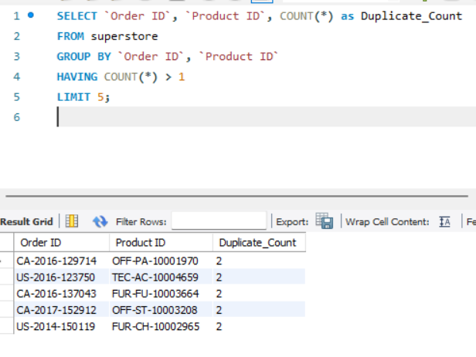

-- STEP 7: VALIDATE RESULTS-
-- Objective: Ensure all data was loaded correctly (Row counts)
SELECT COUNT(*) AS Total_Rows
FROM superstore;
